Walk On by Nancy Buchanan
Student’s Name
Institutional Affiliation
Course Code and Number
Instructor’s Name
Date
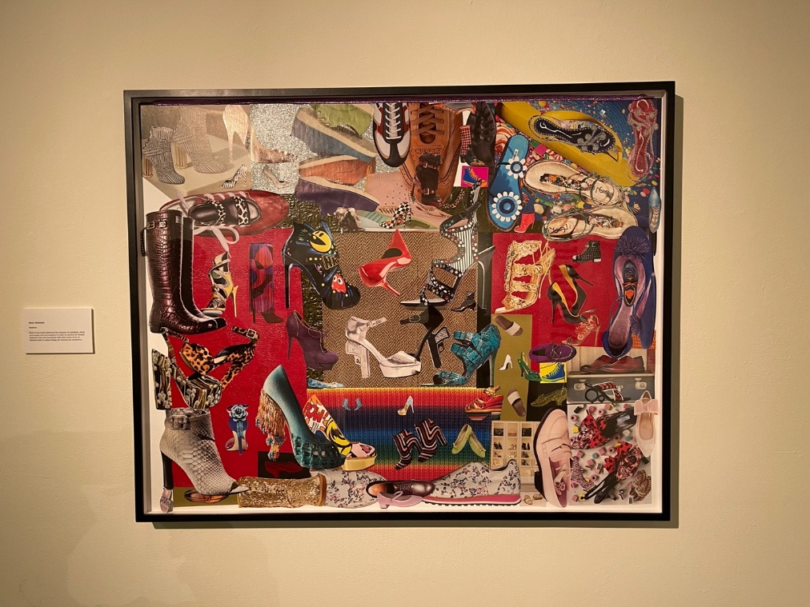

Walk On by Nancy Buchanan
Walk-on is a painting artwork made by Nancy Buchanan. Nancy begins by delving into the relationship between seeing and knowing, examining how our preconceptions influence our perception of a painting. Nancy Buchanan is an American artist who lives and works in Los Angeles. She is best known for her installation, performance, and video art. In the 1970s, she was a crucial figure in the feminist art movement in Los Angeles, which she helped to create. Nancy Buchanan's artwork employs various media to bring societal truths into focus, all of which are based on her personal experience of living through history. She was best known for her performances in the 1970s and 1980s, but she dabbled with video production while finishing drawings and installations. Walk on painting brings personal experience of living.
According to Berger, “An image is a sight which has been recreated or reproduced ... which has been detached from the place and time in which it first made its appearance.” Theoretically, images were initially created to represent something that did not exist and later acquired an additional level of meaning by surviving a more extended period than the original subject. The image now depicted how the topic had appeared to other individuals in the past. In later years, as individuals' consciousness grew, the image came to be recognized as representing a specific artist's vision. Nothing else does such an excellent job of documenting the past, and the more imaginative the work, the more comprehension of the artist's perception of the world. Unfortunately, when images from the past are presented as works of art, the meaning of the images is clouded by learned assumptions about beauty, truth, form, and other aspects of art. On the other hand, the cultural mystification has the effect of making the images appear more distant while also allowing us to draw fewer implications from history.
The artwork is made with skills to illustrate beauty. The image shows women's shoes of a different kind and how they are used to define a woman. It also explains how the shows represent them in public. Publicity and media persuade people that such a transition has occurred by portraying images that appear to have undergone such a transformation and are, as a result, enviable. Glamour is defined as the state of being admired or envied by others. Publicity is the process of creating a sense of glitz and glamour. It is critical to distinguish between publicity and the enjoyment of benefits that can be derived from the products or services that are advertised. Publicity is effective precisely because it is based on the real world of people and events. The shoes in the image are a representation of genuine pleasures in and of women. The first step in public relations is to appeal to people's innate need for pleasure. Nonetheless, it cannot provide the true object of pleasure, and there is no compelling substitute for pleasure in the sense that pleasure is defined.
The publicity is explained and justified as a competitive medium for women's shoe preference which benefits the public who are the consumers. It has a close relationship with certain ideas of freedom of choice for the consumer-women. Freedom of enterprise for the manufacture. Moreover, it persuades a transformation by showing individuals who have apparently been transformed as a result of enviableness. It then constitutes to glamour. A primary goal of public relations is to make the consumer or audience members mildly dissatisfied with their current way of life, not with society's way of life, but with their way of life inside society. When looking at the Walk on graphic, it appears to suggest that if someone purchases what it is promoting, their life will improve. It provides him with a more effective alternative to what he is currently doing.
Berger contends that it is not the quality of a painting or the significance of its message that determines its value, but rather the picture's individuality. In photography, as opposed to painting, it is feasible to make a large number of duplicates that are the same. Many would say that this is one of the most important aspects of photography and that it is one of the characteristics that distinguishes it as a democratic medium. This greater price is justified by the notion that a vintage print will more accurately depict the photographer's original vision of the subject. In light of Berger, he illustrates the understanding of the personalities based on the paintings; “because it corresponds to our own observations of people, we still live in a society of comparable social relations and moral value”. Artists locate a photograph that they believe conveys a clear message and analyze it to identify portions of it that convey a different message, whether viewed separately or in connection with other portions. Thus, overconsumption may cause over the interpretation of the theme of corruption of the art message to the audience.

References
Berger, J. (2018). Ways of seeing. In Living with Contradictions (pp. 189-198). Routledge.

